Covariance is a measure of how changes in one variable are associated with changes in a second variable. Specifically, covariance measures the degree to which two variables are linearly associated. However, it is also often used informally as a general measure of how monotonically(either entirely non-increasing, or entirely non-decreasing.) related two variables are.

In layman’s term let’s say there are two RV X & Y so:

1. If X increases with increase in Y or vice versa then it’s called positive co-variance.
2. If X decreases with increase in Y or vice versa then it’s called negative co-variance.

Basically here we are finding relation between two variables.

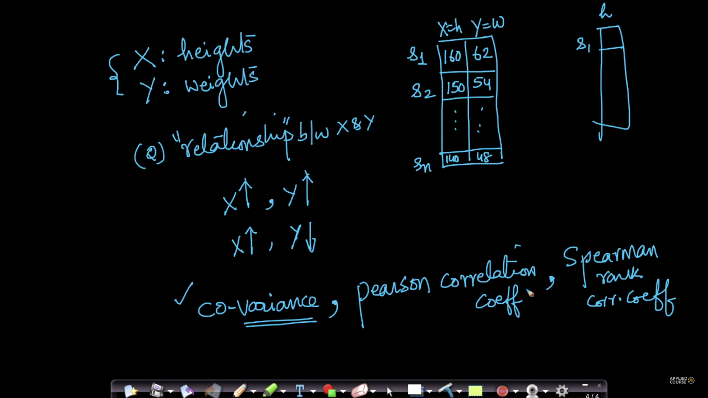

Formula for co-variance is mentioned in below fig:

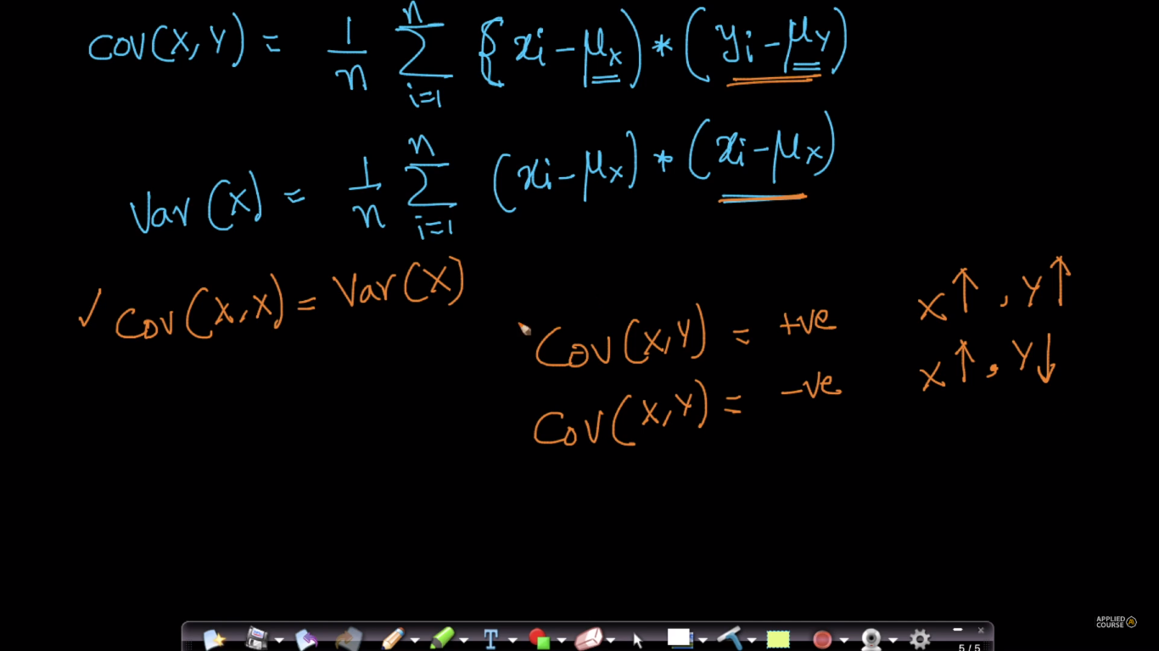

Proof of co-variance formula:

In below fig: we calculate co variance and see that for +ve co-variance we are getting positive results each time, and for -ve co-variance we are getting negative results each time

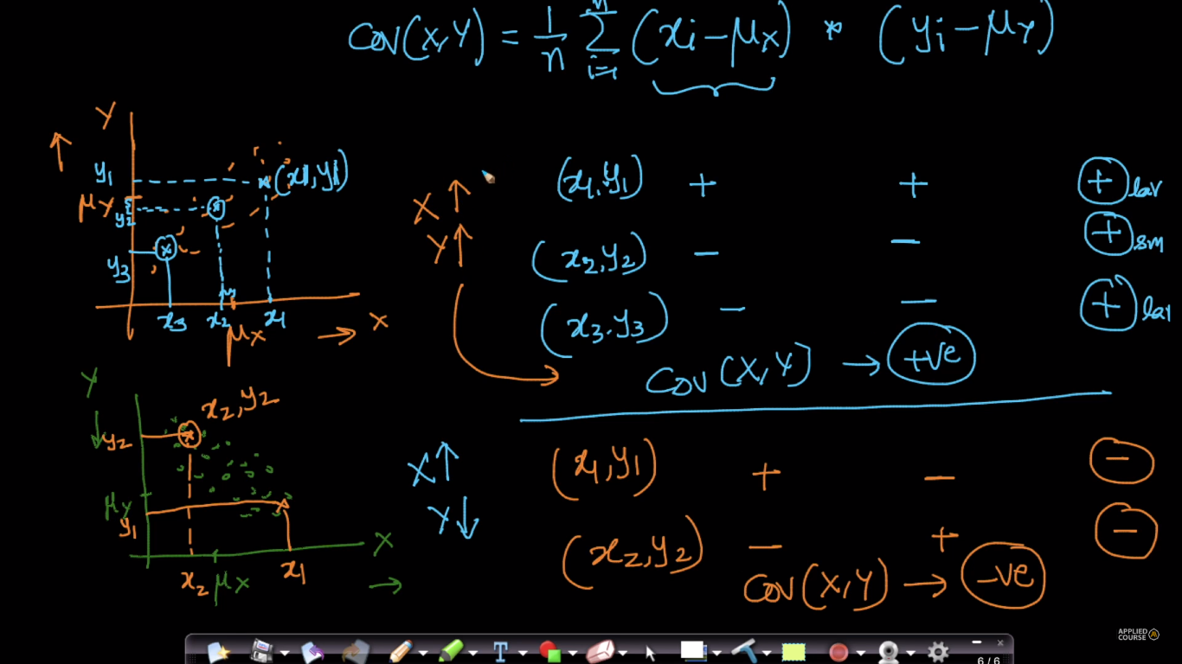

**Limitation of Co-variance:**

Suppose we calculate the co-variance for height with unit in cm and weight in unit kg, and again we calculate co-variance for height with unit feet and weight with unit lbs, then both co-variance will not be equal.

That is for same R.V’s if find co-variance with different metrics then they will be different and this is the biggest limitation of co-variance, to overcome this we use pearson correlation coefficient.

Note: here signs of co-variance that means positive co-variance would not become -ve co-variance, only magnitude will,

But why do we bother about magnitude? , well magnitude tells us about how strongly or weakely they are related to each other.

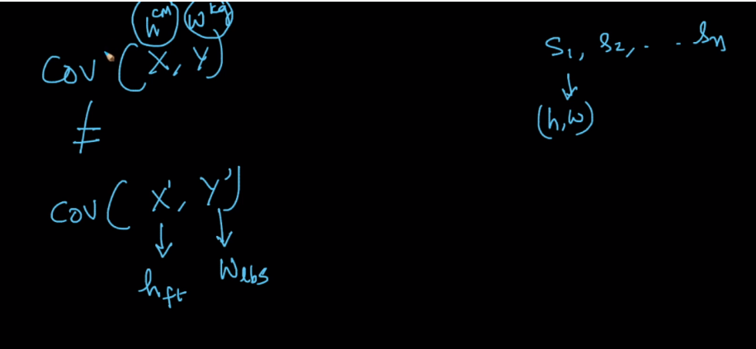

There is one more limitation is that outliers can change the co-variance, because as covariance uses mean value in its formula which is effected by outliers.

Example: Let's say I have a negative covariance in the dataset. I decide to add a record. If the record is an outlier, (Ox - U(X))*(Oy - U(Y)) and the point may be large enough to change the sign of the covariance. What are your thoughts on this?  
  
Here Ox, Oy are the outliers.  
U(X), U(Y) are means for random variable X and Y respectively.

**Some Comments:**

* What if with increasing X, the Y both increases and decreases. i.e. if graph is a wave like structure?  
  I think co-variance will not be useful in that case . is it right ?

Yes, the covariance will be Zero. If y = sin(x) (or cos) and x covers an integer multiple of periods then cov will equal 0

* sir, if we change the metric system, does the sign of co-variance also change or its just the value of co-variance that changes?

It will just change the value of co variance.